DIVINE WORD UNIVERSITY ENROLMENT SYSTEM

DWU ANROID ENROLMENT APP

# INTRODUCTION

## Purpose and Scope

This section provides a brief description of the Systems Design Document’s purpose and scope of DWU enrolment system.

## Project Executive Summary

The proposed Divine Word Enrolment System which will be entirely based on the Android platform is one of the effective approaches the university can look into at this point of time. The mobile based system is convenient for the registration process to be effective. To be effective means students take less time and effort to be registered and involved less engagement of staffs and resources.

### System Overview

The android DWU Enrolment system is developed using the Android platform. The android platform is based on the Linux kernel, the Delvik VM and libraries. The system can be installing on android phone and tablets for easy access to students for flexible enrolment. The system contains four activities or phases, the main form, the login form, the sign up form and the registration form that includes the CRUD function. The system will work on phone with the API level of 8 to 19, that means that it will it can work on android phone that has minimum required SDK, Froyo and maximum required SDK Kit Kat installed. The system overview can be fully explained using the system requirement model which includes the class domain diagram, the use case diagram, use case full description, activity diagram and system sequence diagram.

### Design Constraints

The DWU enrolment system is constrain work in an area with high internet connectivity, the system cannot work with minimum SDK less than 8.The design interface is limited to certain mobile device screen resolution.

### Future Contingencies

The system future improvements are to integrate the system to work in different platform such as iPhones, Blackberry, Windows and Symbian. Also the system can be built as hybrid app using HTML5, JavaScript and CSS so that it can be further improved as a web-based application that is dynamic and can be access via uniform resource locater (URL).

## Document Organization

This section describes the organization of the Systems Design Document of Divine Word Enrolment System.

## Points of Contact

The DWU enrolment system core developers are Rex Makusia, Wingki Mainapo and Oswald Kumasi. The point of contact for queries, comments and updates can be address to us through by our contacts.

Contact addresses are;

[rmakusia@student.dwu.ac.pg](mailto:rmakusia@student.dwu.ac.pg)

[wmainapo@student.dwu.ac.pg](mailto:wmainapo@student.dwu.ac.pg)

[okumasi@student.dwu.ac.pg](mailto:okumasi@student.dwu.ac.pg)

## Project References

This section provides a bibliography of key project references and deliverables that have been produced before this point.

## Glossary

Supply a glossary of all terms and abbreviations used in this document. If the glossary is several pages in length, it may be included as an appendix.

ADT- android developer tool

Android – Platform for android devices

CSS – Cascading Style Sheet

CRUD – stands for Create, Report Update and Delete

JavaScript – web language for easy retrieval of

XHTML -

SDK – software development kit

GB – Giga Bytes

Kit Kat – A version of android of with a minimum version of 8

Froyo – A version of android of with a maximum version of 19

# SYSTEM ARCHITECTURE

The android system app architecture includes the following components.

The minimum SDK version of 8 (Froyo)

The maximum SDK version of 19 (Kit Kat)

## System Hardware Architecture

The DWU enrolment android application can be install on android phones with the minimum SDK version 8 and maximum version of 19. The system hardware architecture includes

1 GHz CPU, internal memory of 2GBytes and external memory of 64GBytes, camera of 3MPixels

Figure 1.1

Show the Use case diagram of the DWU enrolment system.

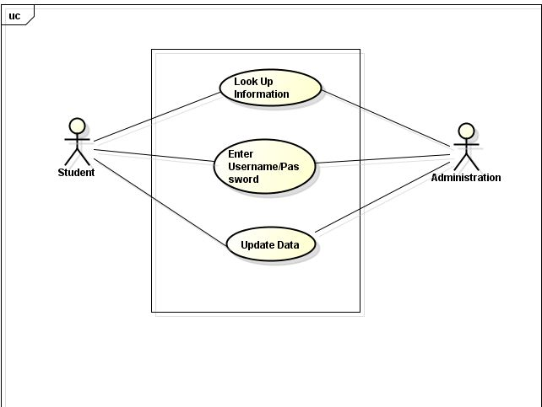

Table shows the Use case fully description.

|  |  |  |
| --- | --- | --- |
| Use Case | Look up information. | |
| Scenario | Look up information online. | |
| Triggering event | New enrolment student wants to look for information online. | |
| Brief description | New enrolment student wants to know about some information especially the faculty and the courses. | |
| Actors | Student | |
| Related Use Cases | Might invoked Enter *Username/ password* | |
| Stakeholders | Administration, ICT | |
| Preconditions | All the information must be obvious to the student | |
| Post conditions | Student must be able to see some information of their likes and for the different courses as well. | |
| Flow of activities | Actor | System |
| 1. Student search for the information 2. Student can choose whatever the faculty he/she wishes | 1. The system allow scroll down so that the information is being shown. 2. The system are flexible |
| Exception conditions | Incorrect login password  Incorrect username | |

|  |  |  |
| --- | --- | --- |
| Use Case | Enter password/ Username | |
| Scenario | Allow for the student to login | |
| Triggering event | New enrolment student wants to access the enrolment form | |
| Brief description | New enrolment student wants to fill in the form in order to be enrolled. | |
| Actors | Student | |
| Related Use Cases | Might invoked Enter *update data* | |
| Stakeholders | Administration, ICT | |
| Preconditions | The username must be valid or active. | |
| Post conditions | Login into the system  Account created and saved | |
| Flow of activities | Actor | System |
| 1.Student enter the password  2.Student enter the username | 1. The system require for both the username and password 2. The password and username matched. |
| Exception conditions | Incorrect login password  Incorrect username | |

|  |  |  |
| --- | --- | --- |
| Use Case | Update the data | |
| Scenario | Registrar wants to Update the data | |
| Triggering event | Registrar wants to delete and add new student information | |
| Brief description | Registrar wants to delete and add new information into the database | |
| Actors | Registrar | |
| Related Use Cases | Might invoked Enter Username/ password | |
| Stakeholders | Administration | |
| Preconditions | Database are available  Data of student are available | |
| Post conditions | Registrar must create and saved  Database are being updated | |
| Flow of activities | Actor | System |
| 1. registrar delete the outdated data 2. registrar enter new data of student record | 1. Update the database with the new updated data. 2. New information for the viewers |
| Exception conditions | Incorrect login password  Incorrect username | |

Figure 1.2

Diagram shows the class domain diagram of DWU enrolment system.

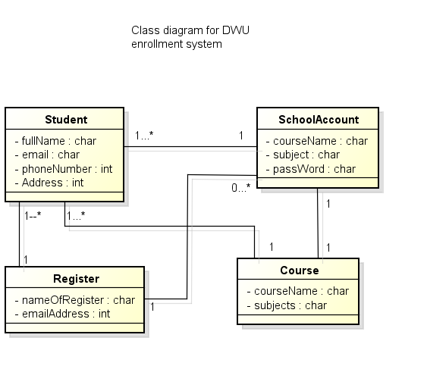



Figure 1.3

Show the activity diagram (below) of the DWU android enrolment system. The activity diagram basically shows how each activity process.

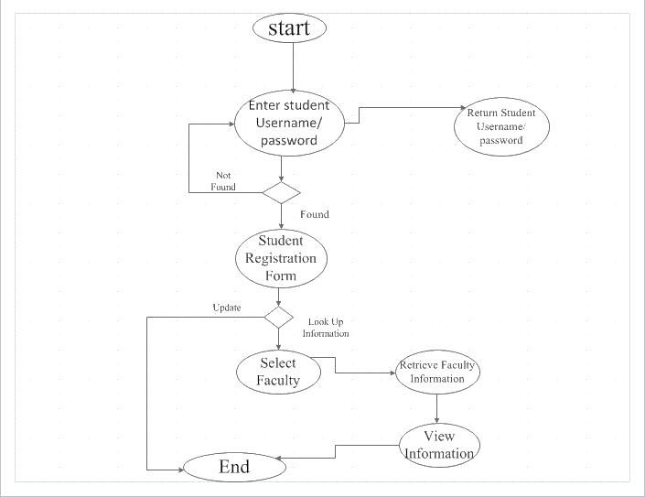

Figure 1.4

Diagram below shows the system sequence diagram of the DWU android enrolment system.

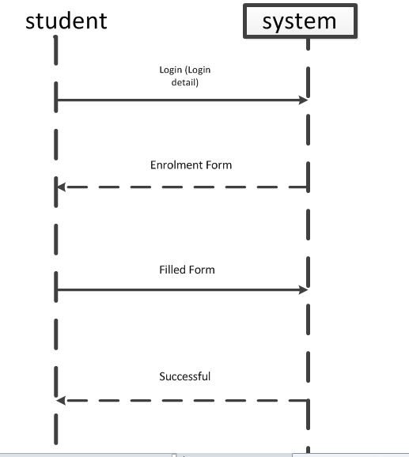

## Figure 1.5

Diagram below shows the design class of DWU enrolment system.



Figure 1.6

Diagram below shows the interactive Diagram of DWU enrolment system.

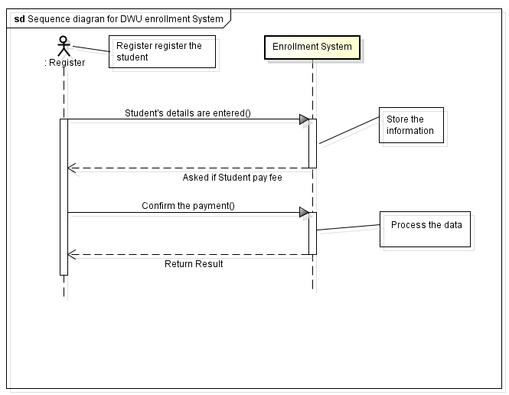

Figure 1.7

Diagram below shows the component diagram of DWU enrolment System.

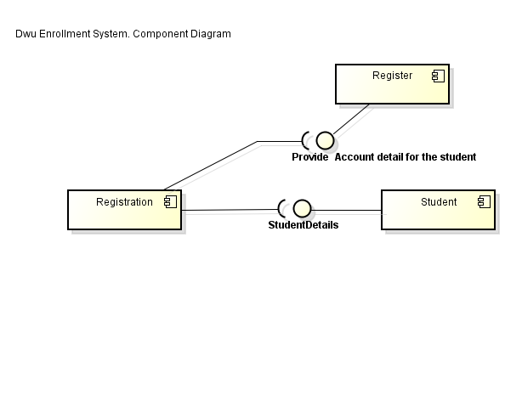

## Figure 1.8

Diagram show the package Diagram of DWU enrolment system.

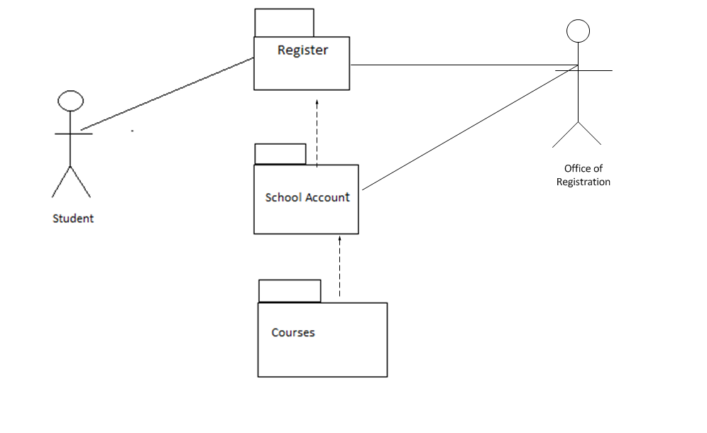

## Figure 1.9

Diagram shows the ERD diagram of DWU enrolment system.

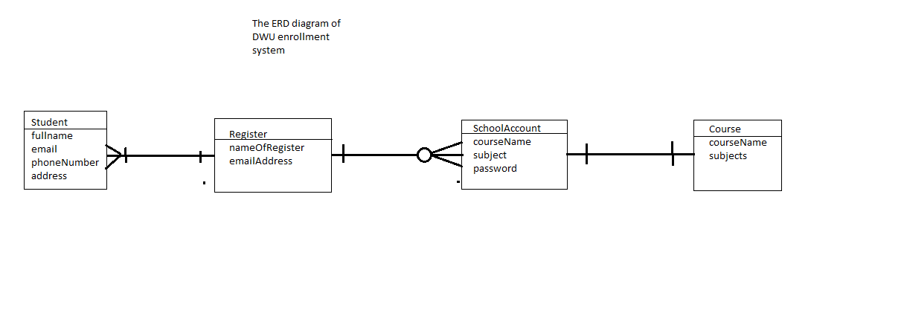

## 2.2 system Software Architecture

The DWU enrolment system is an android mobile application built using the android developer tool. The android developer tool comprise of Java programing language and Extensible-Markup Language (XHTML). The layout of the application, the buttons, the text fields and image view is hardcoded in XHTML and the classes and adapters for each activity are coded in Java.

## Internal Communications Architecture

The DWU android enrolment system can allow student to enroll either using the available wireless network proxy setting or through the 3G data connection.

# FILE AND DATABASE DESIGN

The DWU android enrolment system uses the default database of android known as SQLite which it has a maximum storage of 256KB. However for further implementation of the system it can use MySQL for its storage since MySQL database has unlimited space for creating reports, tables and queries. The system was able to perform the CRUD functionality given the required data.

## Software Detailed Design

The Divine Word Enrolment System is built using the System Development Life Cycle Process shown in Figure 2.1

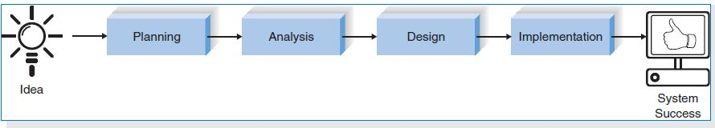

Figure 2.1

System Development Life Cycle

The system was built according to each SDLC phases, the table show each process we carry out in the implementation of the system.

|  |  |
| --- | --- |
| Phases | Task |
| Planning | The developers identified why we have to build, or upgrade the Divine Word enrolment system and the steps we need to implement the system. |
| Analysis | The analysis part involves determine the ways the DWU enrolment android systems is to be analyzed. It is like answering the question who, what and where the system going to be used. |
| Design | In designing the DWU enrolment system is to decide how the DWU enrolment system will operate in terms of hardware, software and network infrastructure that will need in place. |
| Implementation | In implementation of DWU enrolment system the android after being coded it is then install. But first of all the DWU system has to be tested out. In this case the testing is done using the Genymotion emulator. |

## Interface Detailed Design

The Divine Word Enrollment System contains four activities

1. The Main Menu

The main screen is shown below.

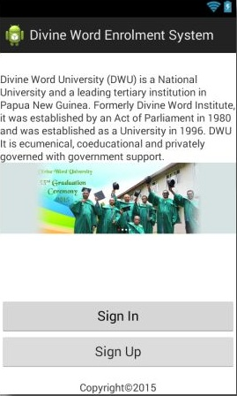

The main menu includes contains the buttons, image view and text field.

The sign button launches the login form. If the password and user name is valid it launches the registration form.

The sign up button launches the sign up form to create an account.

1. The Login Form

The main form is shown below.

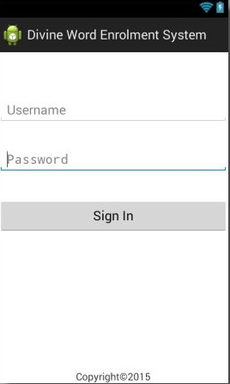

The login form contains two text fields for the password and username and a sign up. The sign up button checks the SQLite database and if the username and password exist and loads the registration form.

1. The Sign up

The sign form is shown below

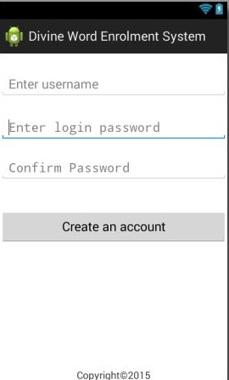

1. The Registration

The registration is shown below

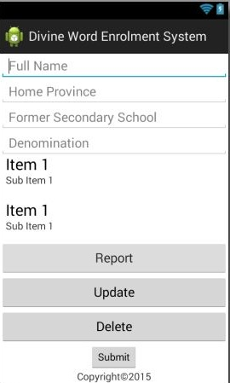

Acknowledgement

Special thank you to Mr.Damio for teaching this unit. The ICT people for some handy information. Louis Ronald for creating the Logo for the system and Mrs. N’drawer for helping us in some information on how to register the students.

Author

Wingki Mainapo, Rex Makusia, Oswald Kumasi are second year students DWU, studying Bachelor in Mathematics and Computer Science at DWU campus.

References

Alan Dennis, Barbara Wixom and David Tegarden. (2014). *system analysis and design: An object-oriented Approach with UML.* verginia: wiley.

bentley, w. (20007, may 05). Retrieved may 30, 2015, from system anysis and design methods: www.mheducation.com

Chon abraham, I. J. (2011). A case study at the federal financial Institutes. *Emerging trends in computing and information sciences*, www.cisjournal.rog.

kendall, k. E. (2013). *System Analysis and Design .* New York: prentice Hall.

stanley, g. (2010, may 06). *system analysis web sites*. Retrieved may 30, 2015, from information system: www.umsl.edu

*tool kit*. (2014, november 04). Retrieved may 28, 2015, from mind tools.com: www.mindtool.com/pages/article/newTMC_04.htm

University, A. (2013, september 05). *athabasca Univesity*. Retrieved may 30, 2015, from computer science: www.athabacau.ca/courses/index.php